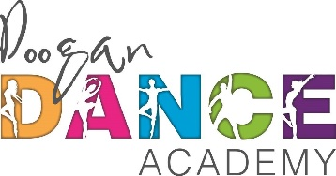

**Parental Consent Form**

I/we the parent(s)/guardian(s) hereby give Gillian Doogan & Courtney Doogan permission to use any still and/or moving images, being video footage, photographs and/or frames and/

or audio footage depicting my/our child(ren), on our website.

All images will be taken by a vetted photographer and or Videographer selected by the Doogan Dance Academy for any of the following uses:

* For display on the website to represent the classes.
* For promotional use.
* For marketing of the dance academy

The above consents will apply throughout the world and be for an indefinite Period.

This form is part of your terms and conditions. Please only accept if you fully agree.